Name: Miheer Abhyankar

Assignment - Banking System

SQL

Q1 –

Write an SQL query to Find the average account balance for all customers.

Query - SELECT avg(balance) from ACCOUNTS

Output:

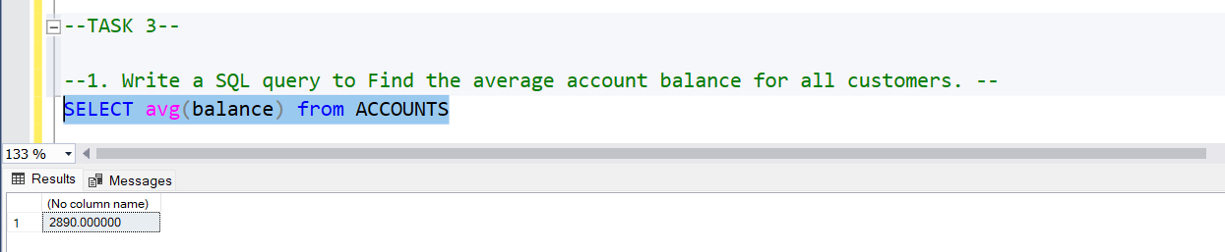

Q2 –

Write an SQL query to Retrieve the top 10 highest account balances.

Query - SELECT TOP 10 customer_id, balance from ACCOUNTS

ORDER BY balance DESC

Output:

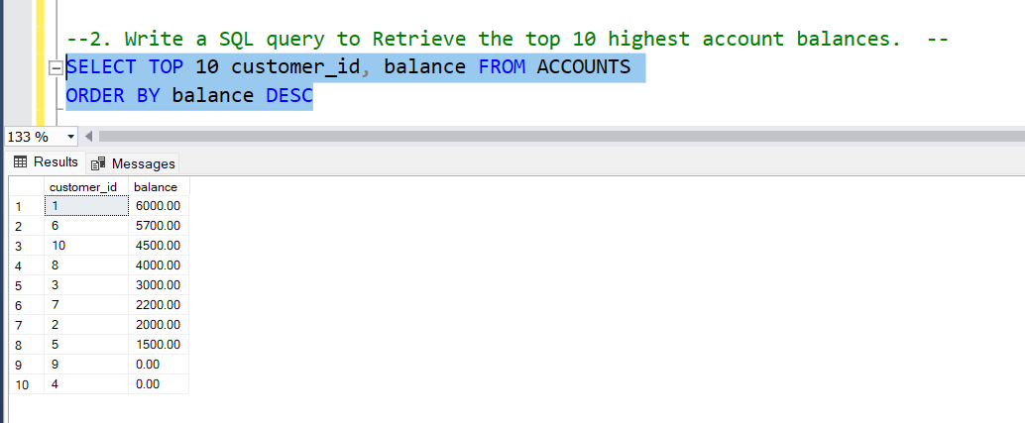

Q3 - Write an SQL query to Calculate Total Deposits for All Customers in specific date.

Query –

SELECT sum(amount) AS total_deposits

FROM Transactions

WHERE transaction_type = 'deposit'

AND CONVERT(DATE, transaction_date) = '2025-03-19'

Output:

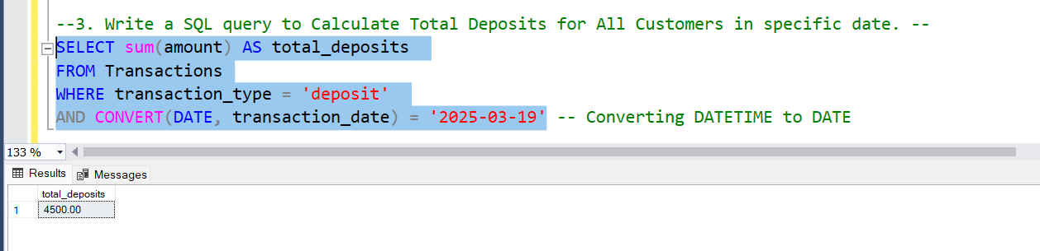

Q4 - Write an SQL query to Find the Oldest and Newest Customers.

Query –

SELECT TOP 1 c.customer_id, c.first_name, c.last_name, a.acc_opening_date

FROM Customers c

JOIN Accounts a ON c.customer_id = a.customer_id

Output:

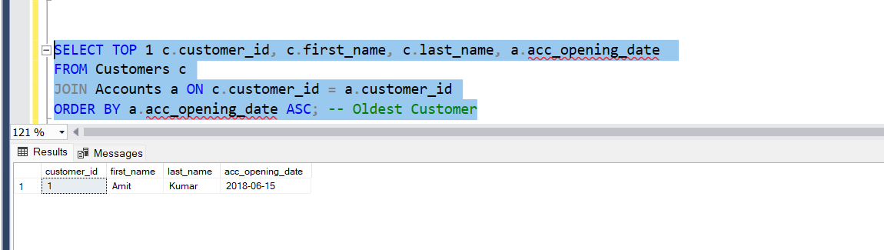

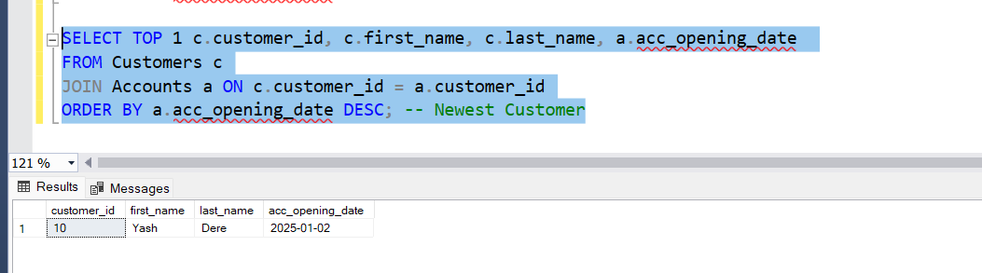

Q5 - Write an SQL query to Retrieve transaction details along with the account type.

Query –

SELECT t.transaction_id, t.account_id, t.transaction_type, t.amount, t.transaction_date, a.account_type

FROM Transactions t

JOIN Accounts a ON t.account_id = a.account_id;

Output:

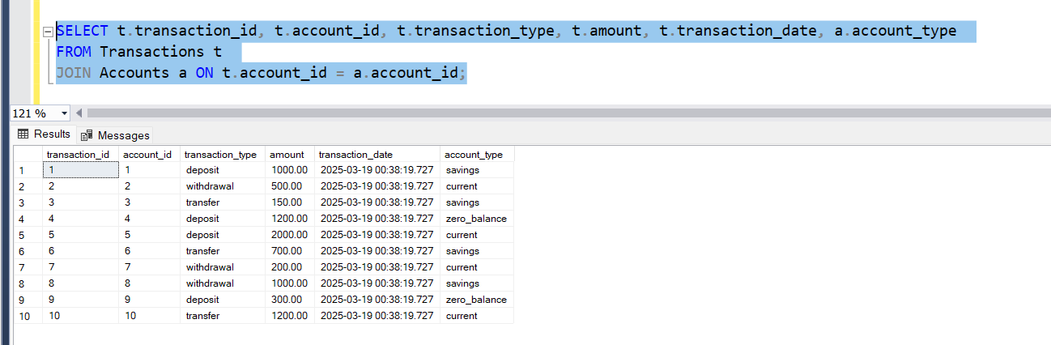

Q6 - Write an SQL query to Get a list of customers along with their account details.

Query –

SELECT c.customer_id, c.first_name, c.last_name, a.account_id, a.account_type, a.balance

FROM Customers c

JOIN Accounts a ON c.customer_id = a.customer_id;

Output:

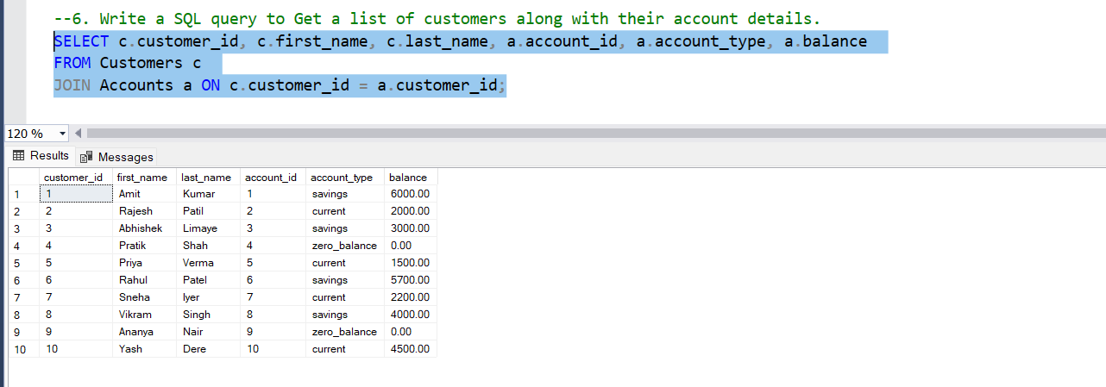

Q7 - Write a SQL query to Retrieve transaction details along with customer information for a specific account.

Query –

SELECT t.transaction_id, t.transaction_type, t.amount, t.transaction_date,

c.customer_id, c.first_name, c.last_name, c.email

FROM Transactions t

JOIN Accounts a ON t.account_id = a.account_id

JOIN Customers c ON a.customer_id = c.customer_id

WHERE t.account_id = 4

Output:

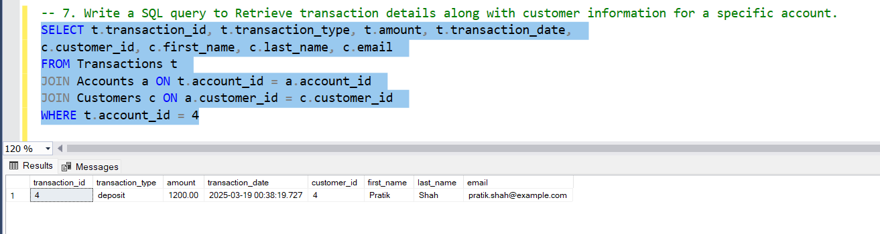

Q8 - Write a SQL query to Identify customers who have more than one account.

Query –

SELECT customer_id, COUNT(account_id) AS account_count

FROM Accounts

GROUP BY customer_id

HAVING COUNT(account_id) > 1;

Output:

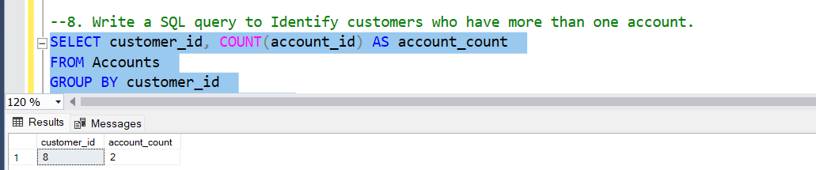

Q9 - Write a SQL query to Calculate the difference in transaction amounts between deposits and withdrawals.

Query –

SELECT SUM(CASE WHEN transaction_type = 'deposit' THEN amount ELSE 0 END) -

SUM(CASE WHEN transaction_type = 'withdrawal' THEN amount ELSE 0 END) AS balance_difference

FROM Transactions

Output:

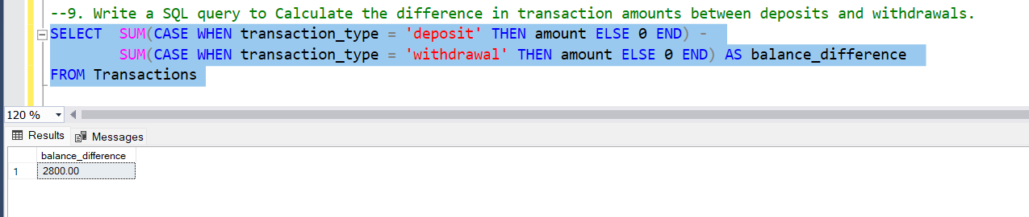

Q10 - Write a SQL query to Calculate the average daily balance for each account over a specified period.

Query –

SELECT account_id, AVG(balance) AS avg_daily_balance

FROM Accounts

WHERE account_id IN (

SELECT DISTINCT account_id FROM Transactions

WHERE transaction_date BETWEEN '2025-03-19' AND '2025-03-24'

)

GROUP BY account_id;

Output:

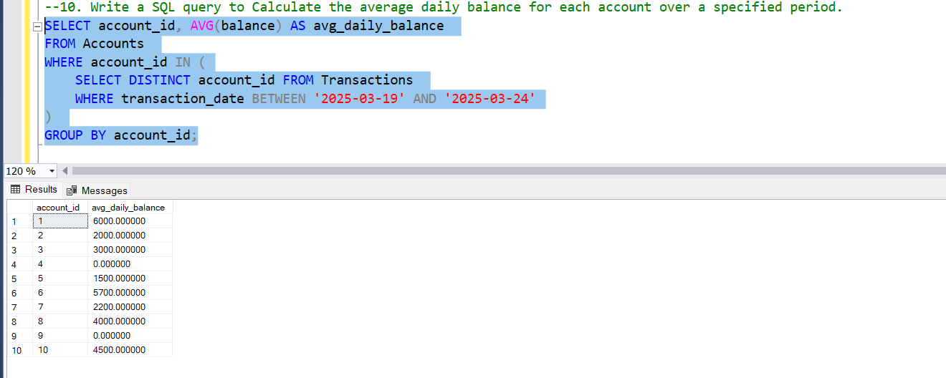

Q11 - Calculate the total balance for each account type.

Query –

SELECT account_type, SUM(balance) AS total_balance

FROM Accounts

GROUP BY account_type;

Output:

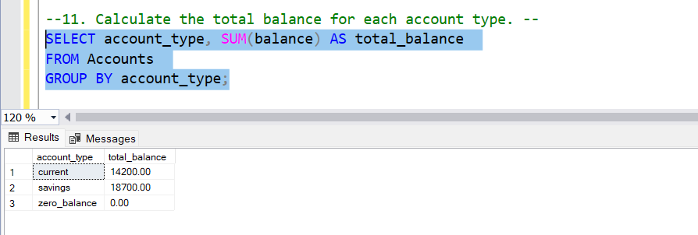

Q12 - Identify accounts with the highest number of transactions order by descending order.

Query –

SELECT account_id, COUNT(transaction_id) AS transaction_count

FROM Transactions

GROUP BY account_id

ORDER BY transaction_count DESC;

Output:

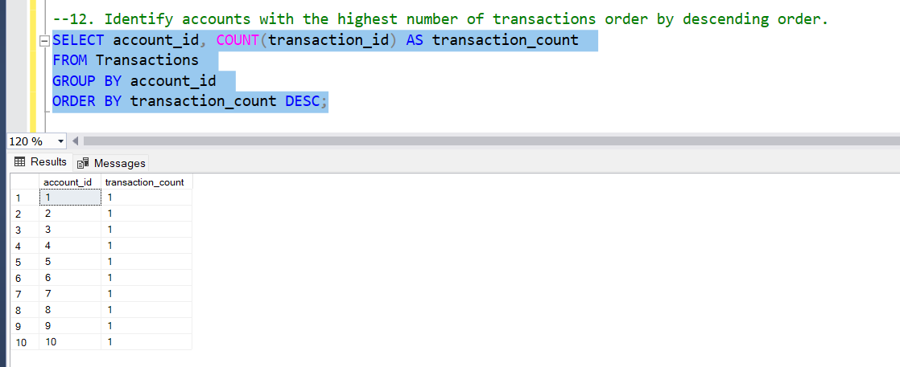

Q13 - List customers with high aggregate account balances, along with their account types.

Query –

SELECT c.customer_id, c.first_name, c.last_name, a.account_type, SUM(a.balance) AS total_balance

FROM Customers c

JOIN Accounts a ON c.customer_id = a.customer_id

GROUP BY c.customer_id, c.first_name, c.last_name, a.account_type

HAVING SUM(a.balance) > 2000

Output:

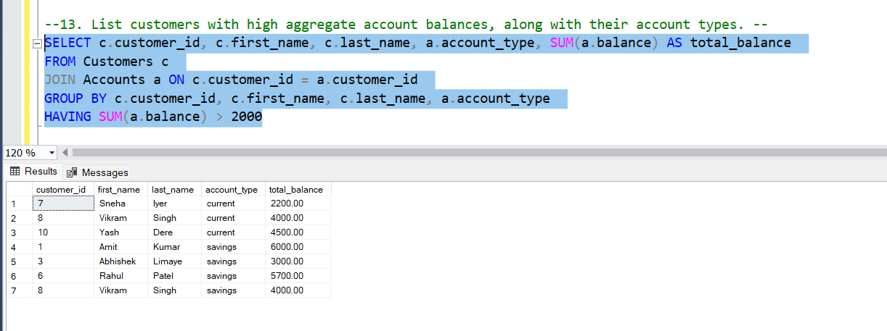

Q14 - Identify and list duplicate transactions based on transaction amount, date, and account.

Query –

SELECT account_id, transaction_date, amount, COUNT(*) AS duplicate_count

FROM Transactions

GROUP BY account_id, transaction_date, amount

